**Connecting Smart Objects**

Connecting Smart Objects IoT devices and sensors must be connected to the network for their data to be utilized. In addition to the wide range of sensors, actuators, and smart objects that make up IoT, there are also a number of different protocols used to connect them. Here the characteristics and communications criteria that are important for the technologies that smart objects employ for their connectivity, along with a deeper dive into some of the major technologies being deployed today.

**Communications Criteria:**

In the world of connecting “things,” a large number of wired and wireless access technologies are available or under development. Before reviewing some of these access technologies, it is important to talk about the criteria to use in evaluating them for various use cases and system solutions.

Wireless communication is common in the world of smart object connectivity, mainly because it eases deployment and allows smart objects to be mobile, changing location without losing connectivity. The following sections take this into account as they discuss various criteria. In addition, wired connectivity considerations are mentioned when applicable.

**Range:**

**Short range**: The classical wired example is a serial cable. Wireless short-range technologies are often considered as an alternative to a serial cable, supporting tens of meters of maximum distance between two devices. Examples of short-range wireless technologies are IEEE 802.15.1 Bluetooth and IEEE 802.15.7 Visible Light Communications (VLC).

**Medium range:** This range is the main category of IoT access technologies. In the range of tens to hundreds of meters, many specifications and implementations are available. The maximum distance is generally less than 1 mile between two devices. **Examples** of medium- range wireless technologies include IEEE 802.11 Wi-Fi, IEEE 802.15.4, and 802.15.4g WPAN. Wired technologies such as IEEE 802.3 Ethernet and IEEE 1901.2 Narrowband Power Line Communications (PLC).

**Long range:** Distances greater than 1 mile between two devices require long-range technologies. Wireless examples are cellular (2G, 3G, 4G) and some applications of outdoor IEEE 802.11 Wi-Fi and Low-Power Wide-Area (LPWA) technologies.

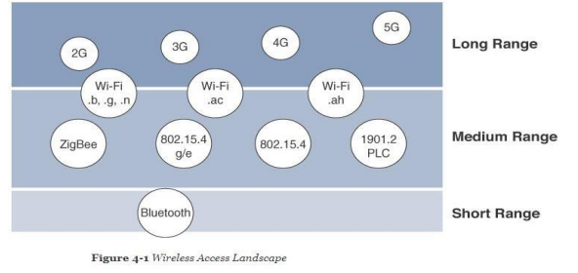

**Frequency Bands:**

Radio spectrum is regulated by countries and/or organizations, such as the International Telecommunication Union (ITU) and the Federal Communications Commission (FCC). These groups define the regulations and transmission requirements for various frequency bands. For example, portions of the spectrum are allocated to types of telecommunications such as radio, television, military, and so on.

**Power:**

**Power** Consumption While the definition of IoT device is very broad, there is a clear definition between powered nodes and battery-powered nodes. A powered node has a direct connection to a power source, and communications are usually not limited by power consumption criteria.

Battery-powered nodes bring much more flexibility to IoT devices. These nodes are often classified by the required lifetimes of their batteries. Does a node need 10 to 15 years of battery life.

**Topology:**

Among the access technologies available for connecting IoT devices, three main topology schemes are dominant: star, mesh, and peer-to-peer. For long-range and short-range technologies, a star topology is prevalent, as seen with cellular, LPWA, and Bluetooth networks. Star topologies utilize a single central base station or controller to allow communications with endpoints. For medium-range technologies, a star, peer-to-peer, or mesh topology is common.

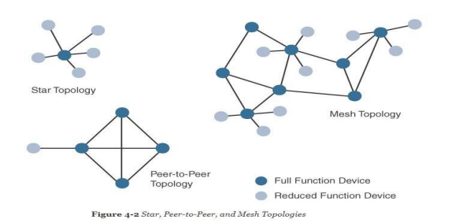

**Constrained Devices:**

The Internet Engineering Task Force (IETF) acknowledges in RFC 7228 that different categories of IoT devices are deployed. While categorizing the class of IoT nodes is a perilous exercise, with computing, memory, storage, power, and networking continuously evolving and improving, RFC 7228 gives some definitions of constrained nodes. RFC 7228, constrained nodes can be broken down into the classes.

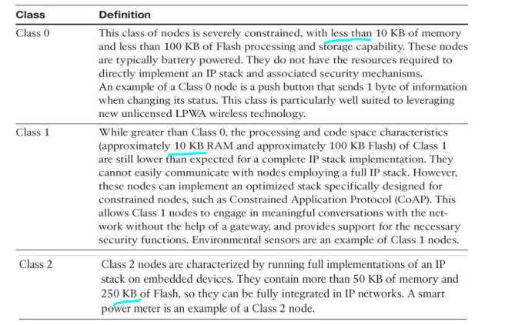

**Constrained-Node Networks**

While several of the IoT access technologies, such as Wi-Fi and cellular, are applicable to laptops, smart phones, and some IoT devices, some IoT access technologies are more suited to specifically connect constrained nodes. Constrained-node networks are often referred to as Low-power and Lossy Networks (LLNs). Low power in the context of LLNs refers to the fact that nodes must cope with the requirements from powered and battery-powered constrained nodes.

**Data Rate and Throughput:**

Data Rate and Throughput The data rates available from IoT access technologies range from 100 bps with protocols such as Sigfox to tens of megabits per second with technologies such as LTE and IEEE 802.11ac. However, the actual throughput is less—sometimes much less—than the data rate.

Short-range technologies can also provide medium to high data rates that have enough throughput to connect a few endpoints. For example, Bluetooth sensors that are now appearing on connected wearables fall into this category.

**Latency and Determinism:**

Much like throughput requirements, latency expectations of IoT applications should be known when selecting an access technology. This is particularly true for wireless networks, where packet loss and retransmissions due to interference, collisions, and noise are normal behaviours.

**Overhead and Payload:**

When considering constrained access network technologies, it is important to review the MAC payload size characteristics required by applications. The minimum IPv6 MTU size is expected to be 1280 bytes. Therefore, the fragmentation of the IPv6 payload has to be taken into account by link layer access protocols with smaller MTUs.

For example, the payload size for IEEE 802.15.4 is 127 bytes and requires an IPv6 payload with a minimum MTU of 1280 bytes to be fragmented. On the other hand, IEEE 802.15.4g enables payloads up to 2048 bytes, easing the support of the IPv6 minimum MTU of 1280 bytes.

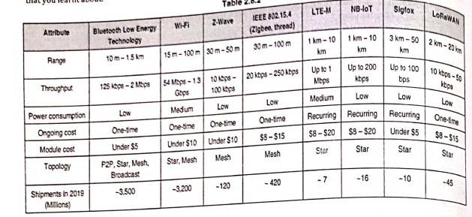

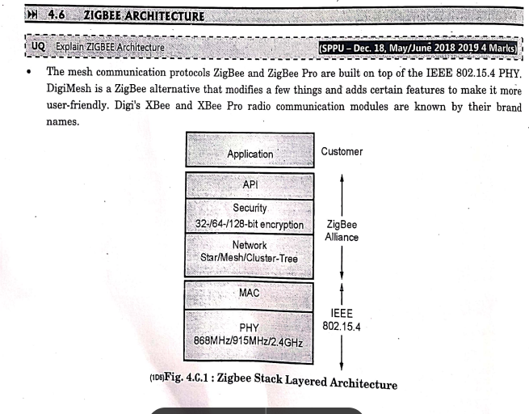

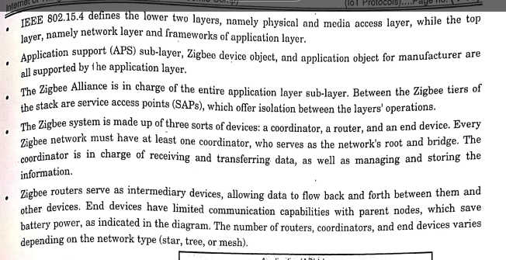

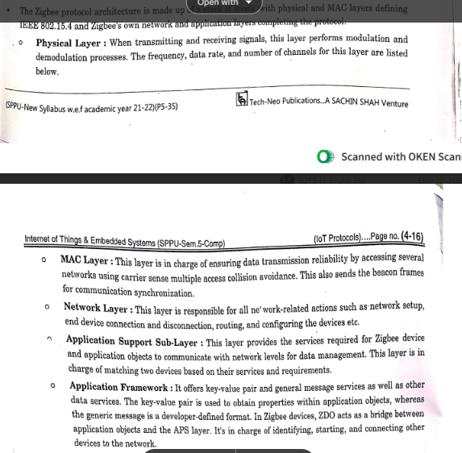

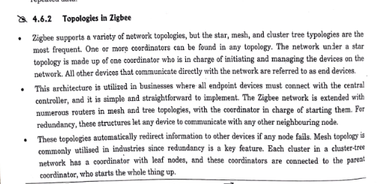

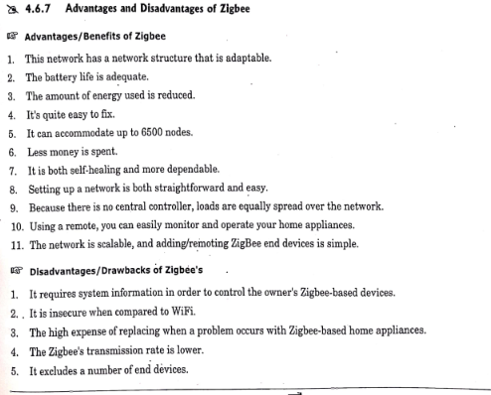

**6LoWPAN**

* 6LoWPAN is an IPv6 protocol, and It’s extended from is IPv6 over Low Power Personal Area Network. As the name itself explains the meaning of this protocol is that this protocol works on Wireless Personal Area Network i.e., WPAN.
* WPAN is a Personal Area Network (PAN) where the interconnected devices are centered around a person’s workspace and connected through a wireless medium.
* You can read more about WPAN at WPAN. 6LoWPAN allows communication using the IPv6 protocol. IPv6 is Internet Protocol Version 6 is a network layer protocol that allows communication to take place over the network.
* It is faster and more reliable and provides a large number of addresses.
* 6LoWPAN initially came into existence to overcome the conventional methodologies that were adapted to transmit information.
* But still, it is not so efficient as it only allows for the smaller devices with very limited processing ability to establish communication using one of the Internet Protocols, i.e., IPv6. It has very low cost, short-range, low memory usage, and low bit rate.

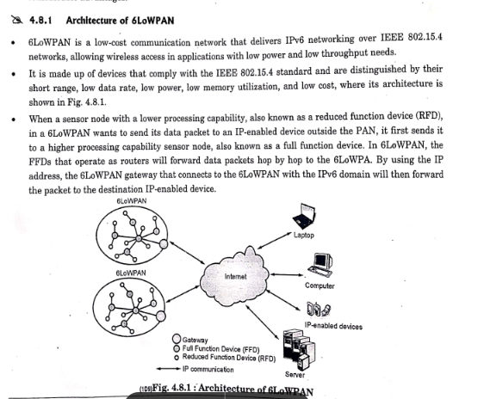

**Features of 6LoWPAN:**

* It is used with IEEE 802.15,.4 in the 2.4 GHz band.
* Outdoor range: ~200 m (maximum)
* Data rate: 200kbps (maximum)
* Maximum number of nodes: ~100

**Advantages of 6LoWPAN:**

* 6LoWPAN is a mesh network that is robust, scalable, and can heal on its own.
* It delivers low-cost and secure communication in IoT devices.
* It uses IPv6 protocol and so it can be directly routed to cloud platforms.
* It offers one-to-many and many-to-one routing.
* In the network, leaf nodes can be in sleep mode for a longer duration of time.

**Disadvantages of 6LoWPAN:**

* It is comparatively less secure than Zigbee.
* It has lesser immunity to interference than that Wi-Fi and Bluetooth.
* Without the mesh topology, it supports a short range.

**Applications of 6LoWPAN:**

* It is a wireless sensor network.
* It is used in home-automation,
* It is used in smart agricultural techniques, and industrial monitoring.

**What Is LoRa®?**

* LoRa (short for long range) is a spread spectrum modulation technique derived from chirp spread spectrum (CSS) technology.
* Semtech’s LoRa is a long range, low power wireless platform that has become the de facto wireless platform of Internet of Things (IoT).
* LoRa devices and networks such as the LoRaWAN® enable smart IoT applications that solve some of the biggest challenges facing our planet: energy management, natural resource reduction, pollution control, infrastructure efficiency, and disaster prevention.
* Semtech’s LoRa devices have amassed several hundred known uses cases for smart cities, homes and buildings, communities, metering, supply chain and logistics, agriculture, and more.
* With hundreds of millions of devices connected to networks in more than 100 countries and growing, LoRa is creating a smarter planet.

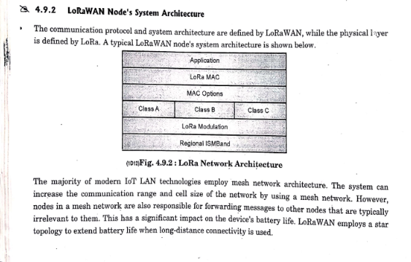

**LTE**

* Mobile phones and data terminals that use the Long Term Evolution Standard (LTE) are subjected to wireless communications and high-speed data transmission standards.
* The GSM/EDGE and UMTS/HSPA network technologies are used as a basis.
* As a result, increased capacity and increased speed are achieved by simplifying the core network and adopting a different radio interface.

**LTE Architecture**

The high-level network architecture of LTE is composed of the following three key components:

* The User Equipment (UE).
* The Evolved UMTS Terrestrial Radio Access Network (E-UTRAN).
* The Evolved Packet Core (EPC).

An improved packet core communicates with packet data networks such as the internet, a company’s private network or the IP multimedia subsystem. The interfaces between the different parts of the system are denoted Uu, S1, and SGi as shown below:

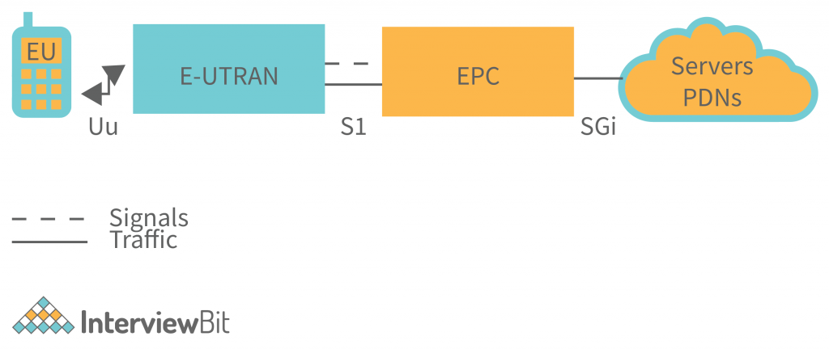

**The User Equipment (UE)**

The internal architecture of the user equipment for LTE is identical to the one used by UMTS and GSM which is actually a Mobile Equipment (ME). The mobile equipment comprised of the following important modules:

* Mobile Termination (MT) : This handles all the communication functions.
* Terminal Equipment (TE) : This terminates the data streams.
* Universal Integrated Circuit Card (UICC) : This is also known as the SIM card for LTE equipments. It runs an application known as the Universal Subscriber Identity Module (USIM).

**The E-UTRAN (The Access network)**

An instance of the evolution of a UMTS Terrestrial Radio Access Network (E-UTRAN) architecture has been illustrated below.

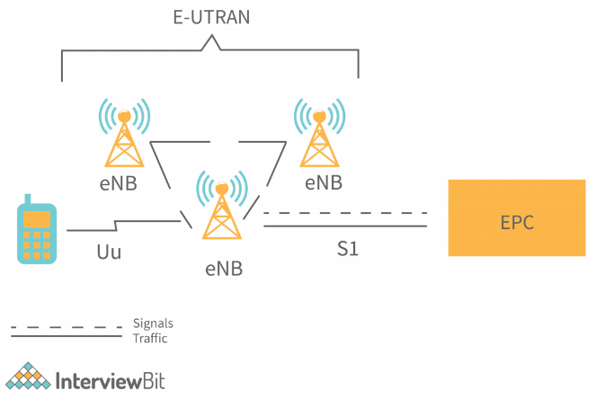

An evolved packet core or ePC controls the various information packets that are sent between mobile devices and the core network. In contrast to an eNB, which is a base station that controls mobile devices in one or more cells, an eNodeB controls radio communication between an evolved packet core or ePC and mobile devices.

An eNB can perform two main functions when connected to an LTE mobile device:

* The eBN sends and receives radio signals to and from all the mobile devices using the analogue and digital signal processing functions of the LTE air interface.
* The eNB sends handover commands to all of its mobiles at a low level, controlling their operation.

**The Evolved Packet Core (EPC) (The core network)**

The architecture of the Evolved Packet Core (EPC) has been revealed in the diagram. Besides, a few elements have not been shown in the diagram for simplicity reasons. The Earthquake and Tsunami Warning System (ETWS), Equipment Identity Register (EIR) and Policy Control and Charging Rules Function (PCRF) are examples of these components.

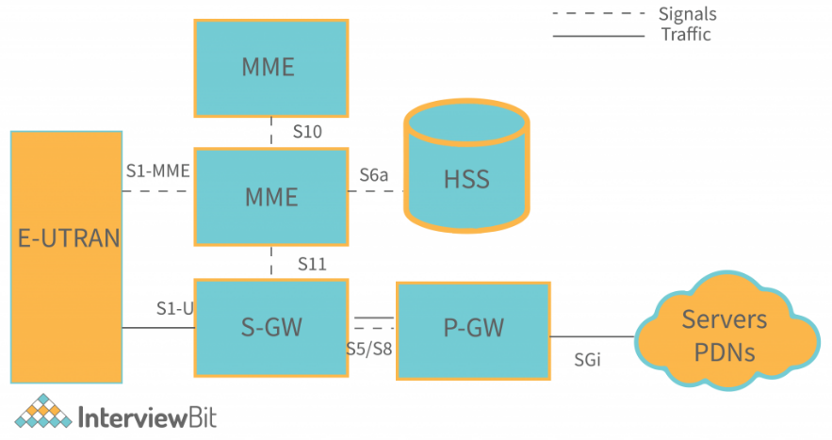

**Below is a brief description of each of the components shown in the above architecture:**

The Home Subscriber Server (HSS) component has been carried forward from UMTS and GSM and is a central database that contains information about all the network operator's subscribers.

The Packet Data Network (PDN) Gateway (P-GW) communicates with the outside world ie. packet data networks PDN, using SGi interface. Each packet data network is identified by an access point name (APN). The PDN gateway has the same role as the GPRS support node (GGSN) and the serving GPRS support node (SGSN) with UMTS and GSM.

The serving gateway (S-GW) acts as a router, and forwards data between the base station and the PDN gateway.

The mobility management entity (MME) controls the high-level operation of the mobile by means of signalling messages and Home Subscriber Server (HSS).

The Policy Control and Charging Rules Function (PCRF) is a component which is not shown in the above diagram but it is responsible for policy control decision-making, as well as for controlling the flow-based charging functionality in the Policy Control Enforcement Function (PCEF), which resides in the P-GW.

**Advantages of LTE Architecture**

* Data and voice can be exchanged between participants using LTE. Because of packet switching, data and voice can be sent using the same network.
* Data sent between the sender and receiver can be high amounts.
* The better life of smartphone batteries is caused by all data exchange being done with very little power consumption.
* It has fast file upload and download speeds.
* It reduces the load on the network by releasing network usage faster.
* Reducing service traffic and favouring fewer crashes is the aim of this initiative.
* You can watch live shows, matches, and events using LTE**.**

**Disadvantages of LTE Architecture:**

* Some cities do not have this service.
* Signals in transit, such as buses and trains, need to be improved by increasing the number of towers and introducing new technologies.
* The complexity of LTE makes it necessary for competent people to manage the system. They might even need to be paid a higher salary.
* Old versions of smartphones cannot make use of this technology.
* The cost of buying new LTE smartphones is high.

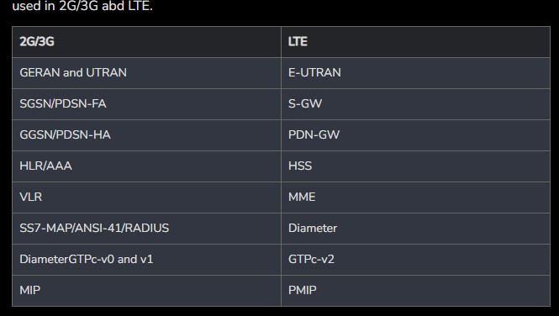

**What is Bluetooth?**

Bluetooth simply follows the principle of transmitting and receiving data using radio waves. It can be paired with the other device which has also Bluetooth but it should be within the estimated communication range to connect. When two devices start to share data, they form a network called piconet which can further accommodate more than five devices.

**Points to remember for Bluetooth:**

* Bluetooth Transmission capacity 720 kbps.
* Bluetooth is Wireless.
* Bluetooth is a Low-cost short-distance radio communications standard.
* Bluetooth is robust and flexible.
* Bluetooth is cable replacement technology that can be used to connect almost any device to any other device.
* The basic architecture unit of Bluetooth is a piconet.

Bluetooth is a short-range wireless LAN technology for connecting small devices and gadgets together and facilitating data transfer among themselves for personal use. Also known as **Bluetooth classic**, it operates in the 2.4 GHz ISM unlicensed bandwidth to communicate among paired devices. Bluetooth classic version comes in two distinct data rate types known as Basic Rate (BR) and Enhanced Data Rate (EDR). It is maintained by Bluetooth Special Interest Group (SIG) and is standardized by IEEE 802.15.

**Bluetooth Low Energy (BLE)** is similar to Bluetooth classic. It is a short-range wireless LAN communication technology standardized by IEEE 802.15. It also operates in 2.4 GHz ISM unlicensed bandwidth. The major distinguishing feature of BLE, commercially made accessible first in 2011, is its low power consumption while maintaining the same communication range as in Bluetooth classic. It typically finds its use in healthcare, fitness, security and home automation appliances that save power.

**Advantage**:

* It is a low-cost and easy-to-use device.
* It can also penetrate through walls.
* It creates an Ad-hoc connection immediately without any wires.
* It is used for voice and data transfer.

**Disadvantages**:

* It can be hacked and hence, less secure.
* It has a slow data transfer rate: of 3 Mbps.
* It has a small range: 10 meters.
* Bluetooth communication does not support routing.
* The issues of handoffs have not been addressed.

**Applications**:

* It can be used in laptops, and in wireless PCs, printers.
* It can be used in wireless headsets, wireless PANs, and LANs.

**Difference between Bluetooth and BLE**

|  |  |  |
| --- | --- | --- |
| **Feature** | **Bluetooth Classic** | **Bluetooth Low Energy (BLE)** |
| Power consumption | High (approx 1W) | Low (approx 0.01W-0.5W) |
| Communication Range | 10m to 30m | 10m to 30m |
| Data Rate | 1Mbps for BR  2-3Mbps for EDR | 500kbps-1Mbps |
| Modulation Technique | GFSK for BR  8-DPSK or π/4-DQPSK for EDR | GFSK |
| RF Bandwidth | 2.4 GHz ISM band (2400-2483.5 MHz) | 2.4 GHz ISM band (2400-2483.5 MHz) |
| Number of Channels | 79 channels each of width 1Mhz | 40 channels each of width 2MHz |
| Spreading | Frequency Hopping Spread Spectrum (FHSS) | Frequency Hopping Spread Spectrum (FHSS) |
| Data link layer protocol | Time Division Multiple Access (TDMA) | Time Division Multiple Access (TDMA) |
| Error detection | 8 bit CRC or 16 bit CRC, and ACKs | 24 bit CRC, ACKs |
| Maximum number of active slaves | 7 | Unlimited |

|  |  |  |
| --- | --- | --- |
| **COMPARISON** | **LORAWAN** | **NB-IoT** |
| Modulation | LORAWAN uses chirp spread spectrum modulation. | NB-IoT uses Quadrature phase shift keying modulation. |
| Frequency | It uses 868MHz in Europe, 915MHz in North America, 433MHz in Asia (Unlicensed ISM bands). | It uses Licensed LTE frequency Bands. |
| Bandwidth | LORAWAN has 250KHz and 125KHz bandwidth. | NB-IoT has 200KHz bandwidth. |
| Maximum message/day | Maximum Message it can send per day is unlimited. | In this technology maximum message/day is also unlimited. |
| Maximum Data Rate | The maximum data rate in case of LoRaWAN is 50Kbps. | The maximum data rate in case of NB-IoT is 200Kbps. |
| Maximum Payload Length | In LORAWAN, the maximum payload length is 243bytes. | In NB-IoT, the maximum payload length is 1600bytes. |
| Range | The Range of LoRaWAN is 5 km in urban, 20 km in rural area. | The Range of NB-IoT is 1 km in urban, 10 km in rural area. |
| Interference Immunity | Interference immunity in case of LORAWAN is very high. | Interference immunity in case of NB-Iot is Low. |
| Authentication and Encryption | It supports AES 128b as encryption technique . | It supports LTE encryption technique. |
| Adaptive Data Rate | LORAWAN supports Adaptive Data Rate (ADR). | It does not support Adaptive Data Rate (ADR). |